Template for Evidence(s)
UI GreenMetric Questionnaire

University : ...
Country : ...
Web Address : …

[4] Water (WR)
SAMPLE
[4.4] Water Efficient Appliances Usage (e.g. hand washing taps, toilet flush, etc.) (WR.4)

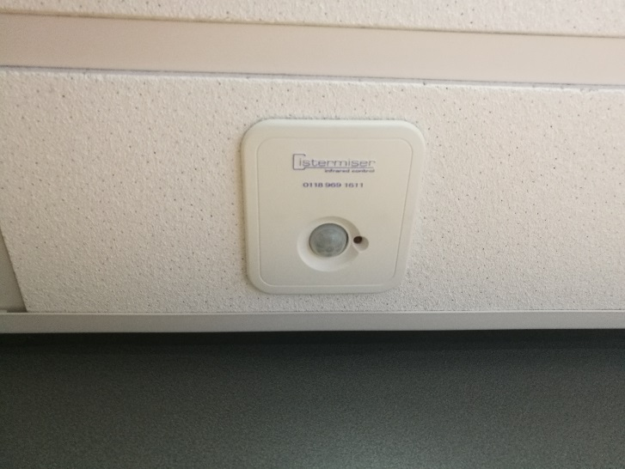 | 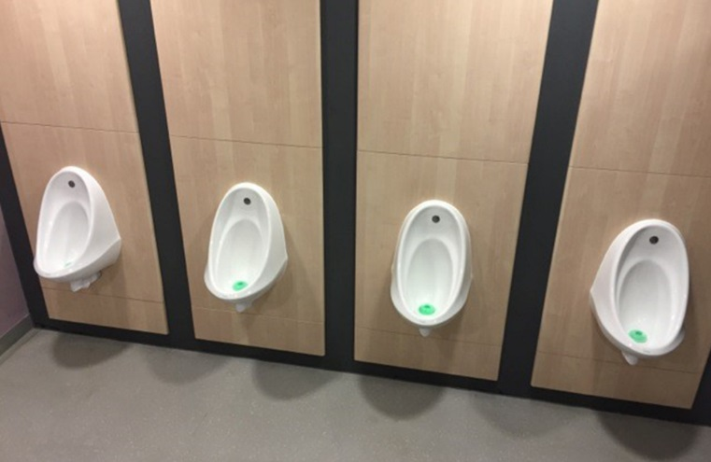
Example of Water Efficient Appliances Usage (University of Nottingham, UK)

Description:
(Please describe the water efficient appliances usage on your campus. The following is an example of the description. You can describe more related items if needed.)

The evidence provided may also include maps showing the location, area size, or distribution of facilities relevant to the indicators

Some examples of water conservation measures include, cistermisers (automatic control of urinal flushing), waterless urinals, low flush WC’s and low flo taps and automatic taps.

Appliance | Total Number | Total number water Efficient appliances | Percentage
Toilet | 250 | 150 | 60%
Wastafel | 150 | 100 | 66%
Etc. | … | … | …
 |  | Average Percentage | 63%

Additional evidence link (i.e., for videos, more images, or other files that are not included in this file):

